**National University of Computer & Emerging Sciences, Karachi  
Fall-2020 CS-Department  
Assignment 2**

**Deadline 16 March 2020 2:30 pm – 3:30 pm**

|  |  |
| --- | --- |
| **Course Code: CS301** | **Course Name: Theory of Automata** |

**Question 1:** **P.D.A.**

1. **Construct an equivalent P.D.A. from following CFG:**

**S🡪 aTb| b**

**T🡪 Ta | ɛ**

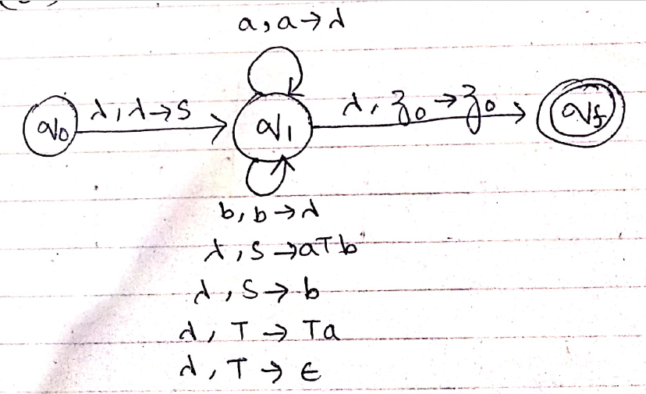

1. **Trace the input sring "aaab" using stack.**

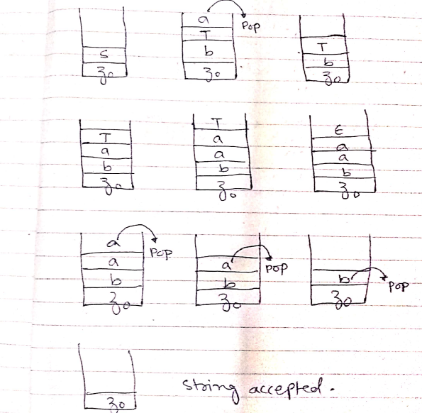

1. **Construct a P.D.A. accepting for the language L ={ a4bn cn|n>0}**



**Question 2:** **P.D.A.**

1. **Construct an equivalent P.D.A. by empty stack, from following CFG:**

**S🡪 0TT**

**T🡪 0S|1S|0**

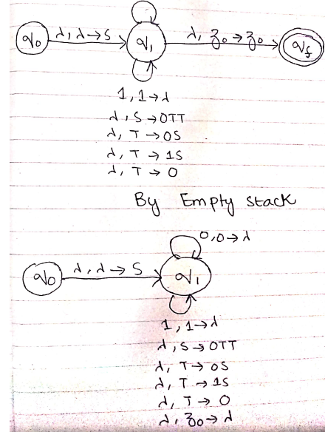

**Question 3:Pumping lemma**

**a) Let L= { bnan | n>0 } then find if L is a regular or non regular language using Pumping Lemma.**

**b) Let L= { (ba)n | n>0 } then find if L is a regular or non regular language using Pumping Lemma.**

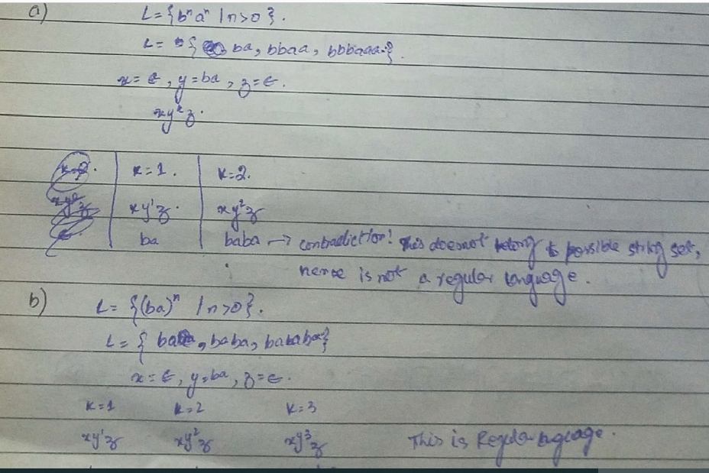



***BEST OF LUCK!***